**Hands – On Lab**

**Workshop 1**

# Survey Form

Using HTML and CSS (inline and internal) only, create a survey form as in the given figure:

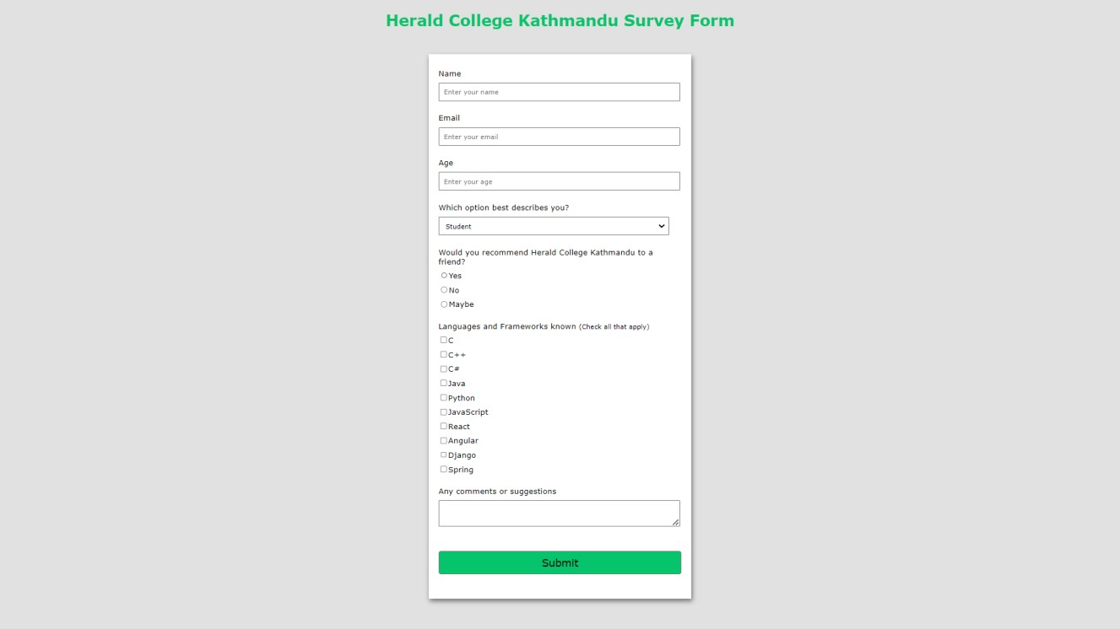

**Link of code:** https://github.com/Aayushrai001/Web-Technology-works/blob/master/Internet_Software_Architecture/workshop1_ISA.html

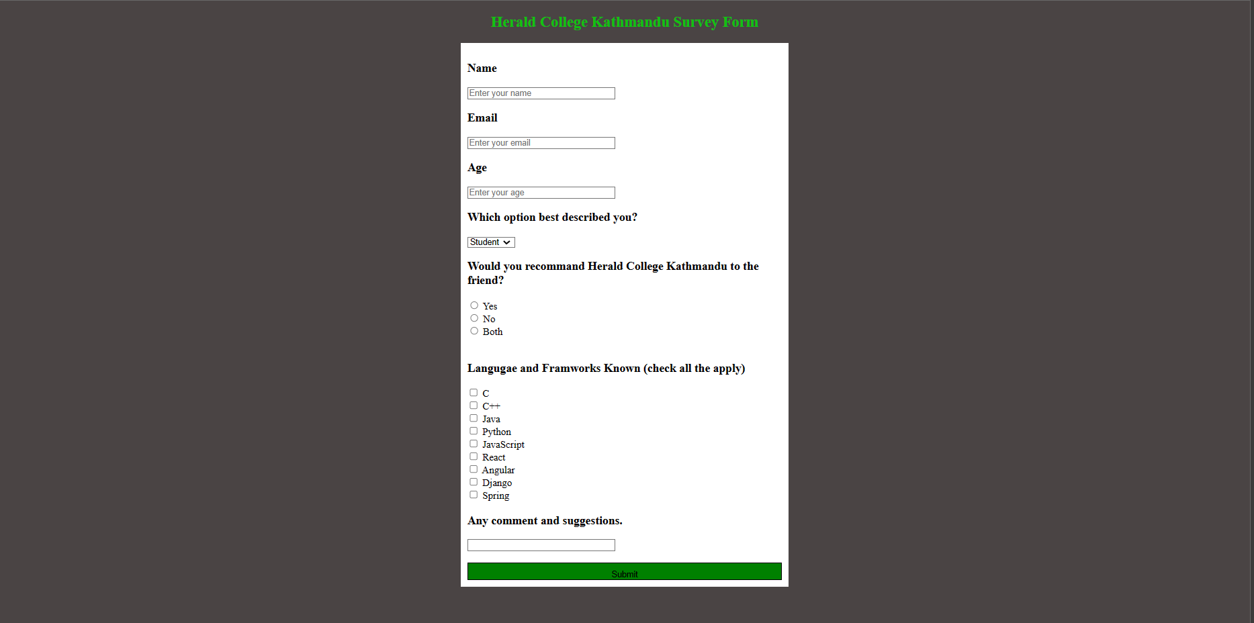

# Creating a Simple Web Page

Create a simple web page which must include the following sections:

1. Logo
2. Navigation Menu (Home, About, Service, Contact)
3. Search Box and icon
4. Heading Text
5. Use of <p> and <span> tag with different styling
6. Button
7. Form
8. Social media icons 9. Footer section

9. Background image

**Link of code:** <https://github.com/Aayushrai001/Web-Technology-works/blob/master/Internet_Software_Architecture/workshop2.html>

**Link of css:** https://github.com/Aayushrai001/Web-Technology-works/blob/master/Internet_Software_Architecture/index.css





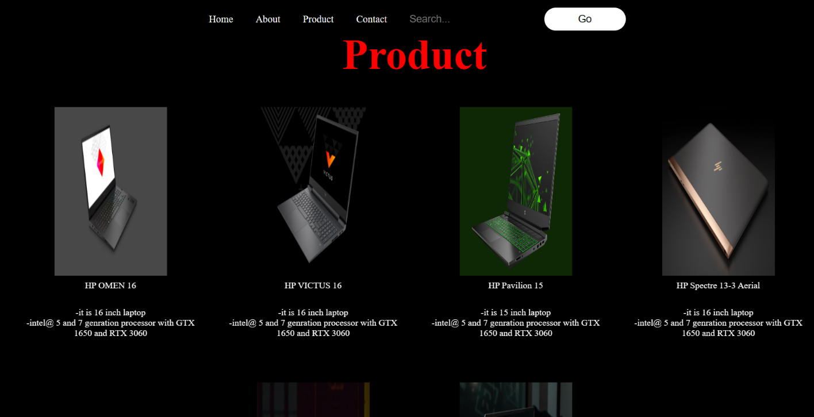

# XAMPP Control Panel

Download and install Xampp Server on your computer and run the web page build in question 1 and 2 using localhost. See the difference between running a page with localhost and directly.

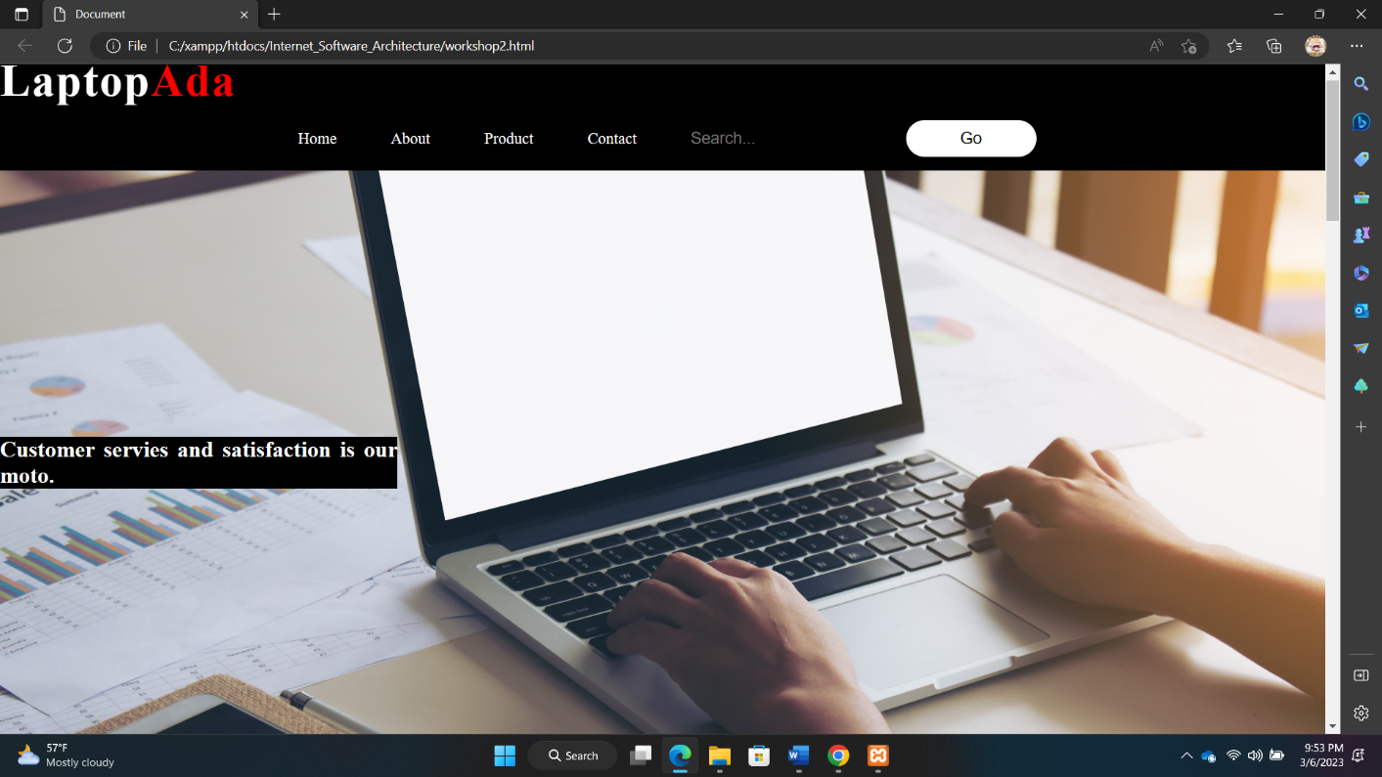

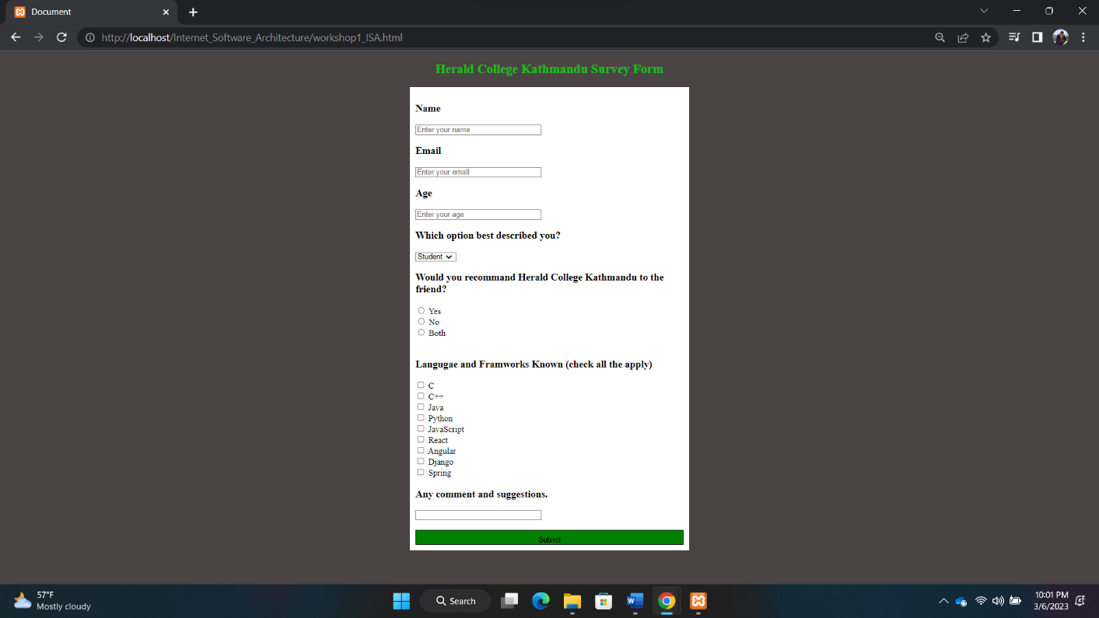

**Ans:** As I had used both question 1 and 2 in localhost and directly, I had seen different in URL, while using directly it show the different URL mainly the location the file of the devices and while using localhost it has localhost in URL of the site. The site opening using localhost run more smoothly than directly that is how I feel while using the site.

# Web Performance Visualization

For the created web pages, visualize the web performance using devtools, following the steps:

1. After running the file in the browser, right click on mouse and go to inspect

2. Check the network and performance options for the visualization

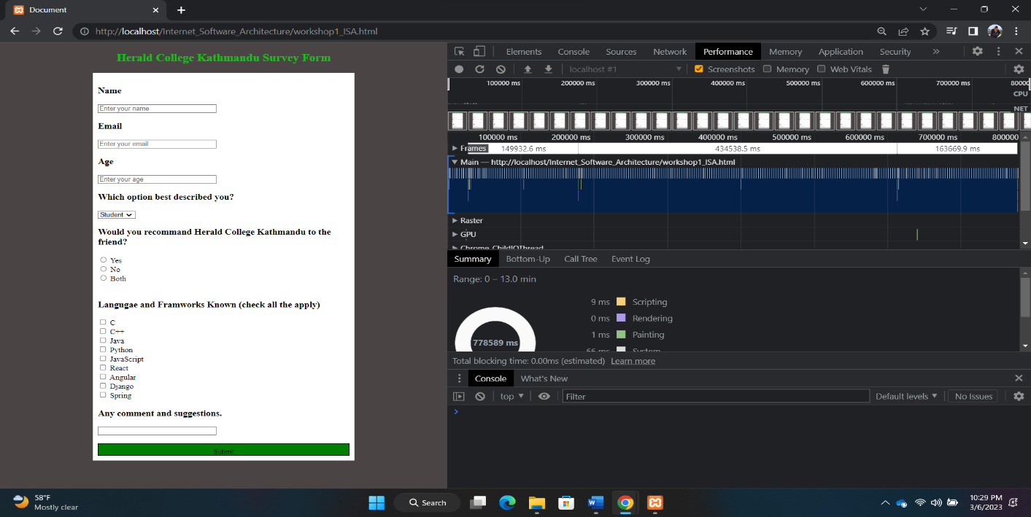

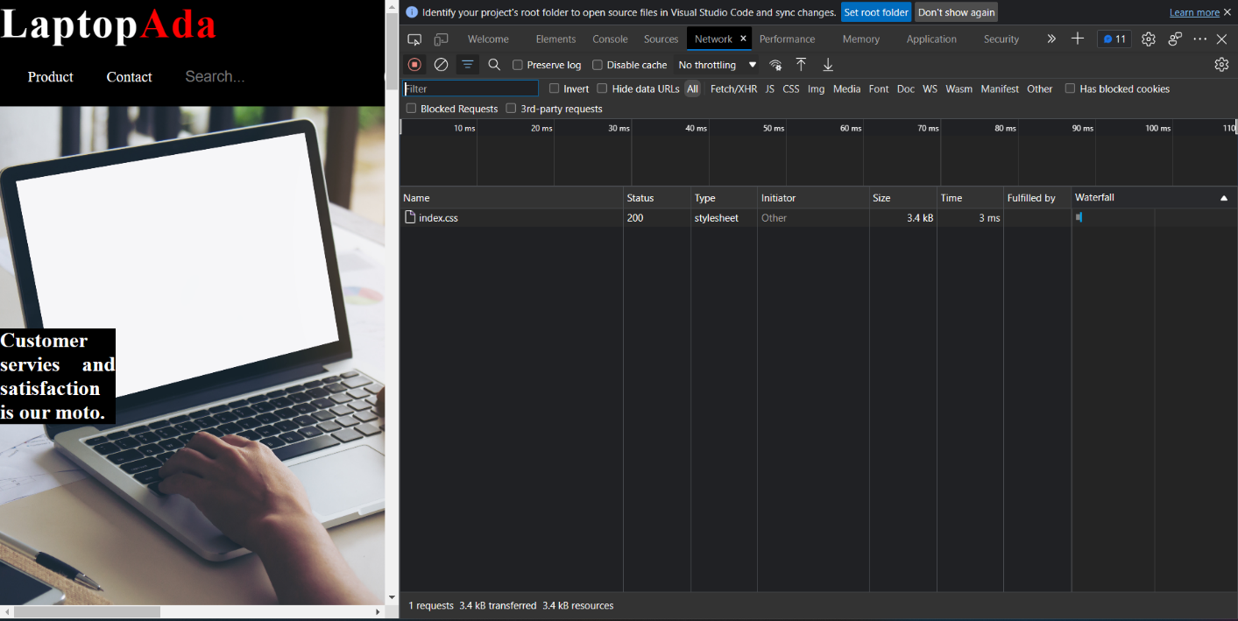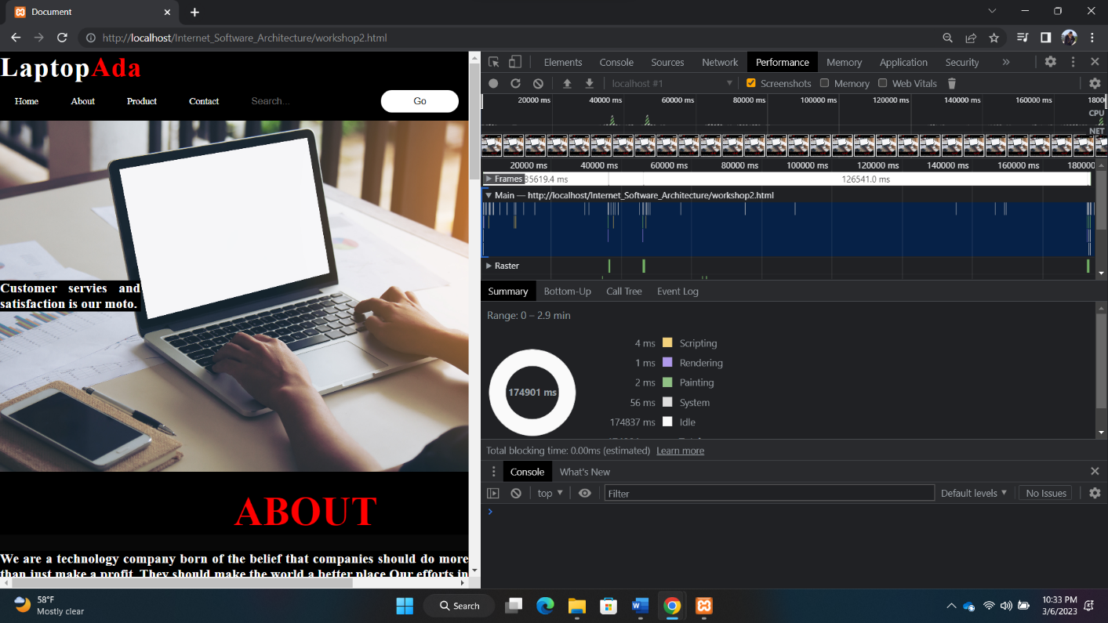

**Ans:** Following a thorough examination of network and performance options. A web browser's network option displays information about the webpage's network activities. This includes details about the resources being loaded, such as images and stylesheets, as well as the time it takes for them to load. The performance option in the web browser displays information about how the webpage is performing. This includes metrics like page load time, time to first byte, and rendering time, as well as information about resources.